TERRAFORM TASK -05
Watch the Terraform-05 video.
- Execute the script shown in the video.
- Open VS Code → open your Terraform folder.
- Create/Open main.tf.
- Add S3 bucket resource code:
- resource "aws_s3_bucket" "s3_bucket" {
- bucket = “my-uniq-bucket-name"
- acl = "private"
- }
- Open Terminal in VS Code.
- Run:
- terraform init
- Confirm message: Terraform has been successfully initialized!
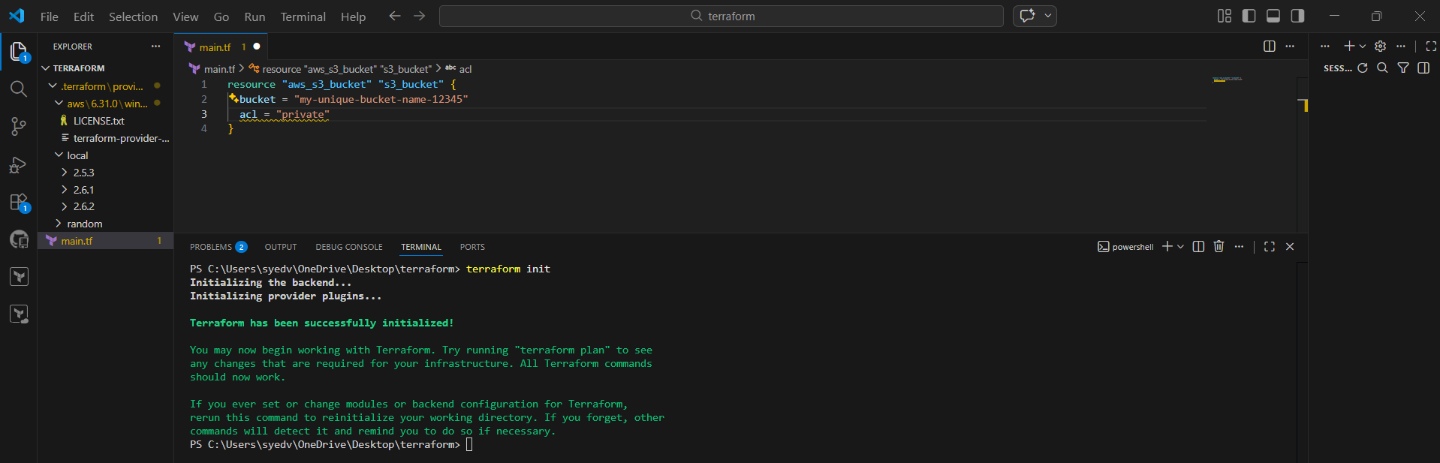
- In VS Code terminal, run:
- terraform apply
- Terraform shows execution plan (what will be created).
- Check that it shows:
aws_s3_bucket.s3_bucket will be created
- Continue to approval step.

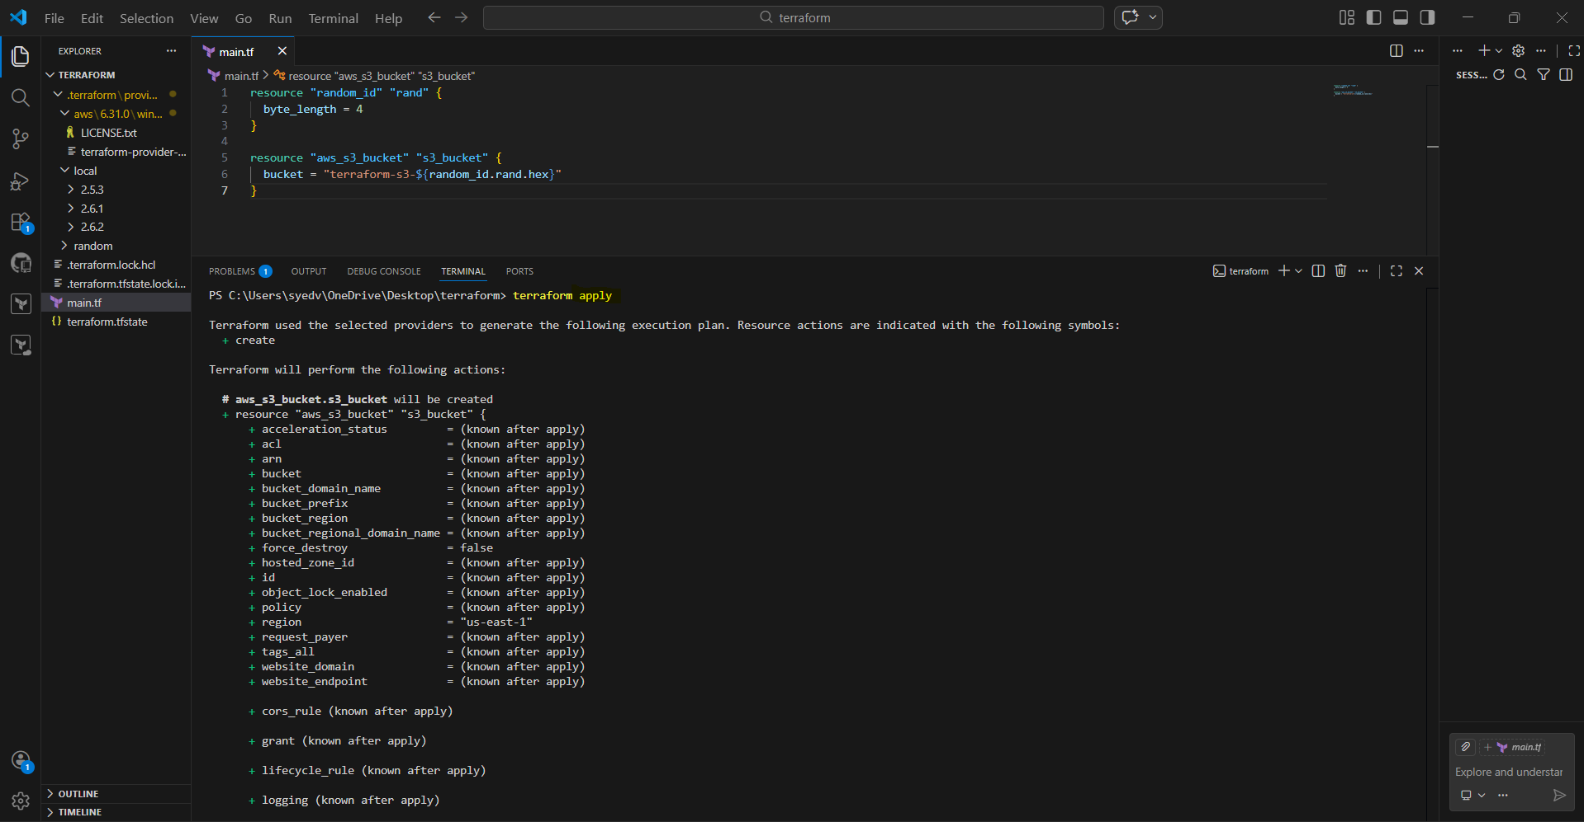
- When Terraform asks:
- Do you want to perform these actions?
- Type:
- yes
- Terraform creates S3 bucket successfully.
- You may see warning:
acl is deprecated
- Confirm success line:
Apply complete! Resources: 1 added
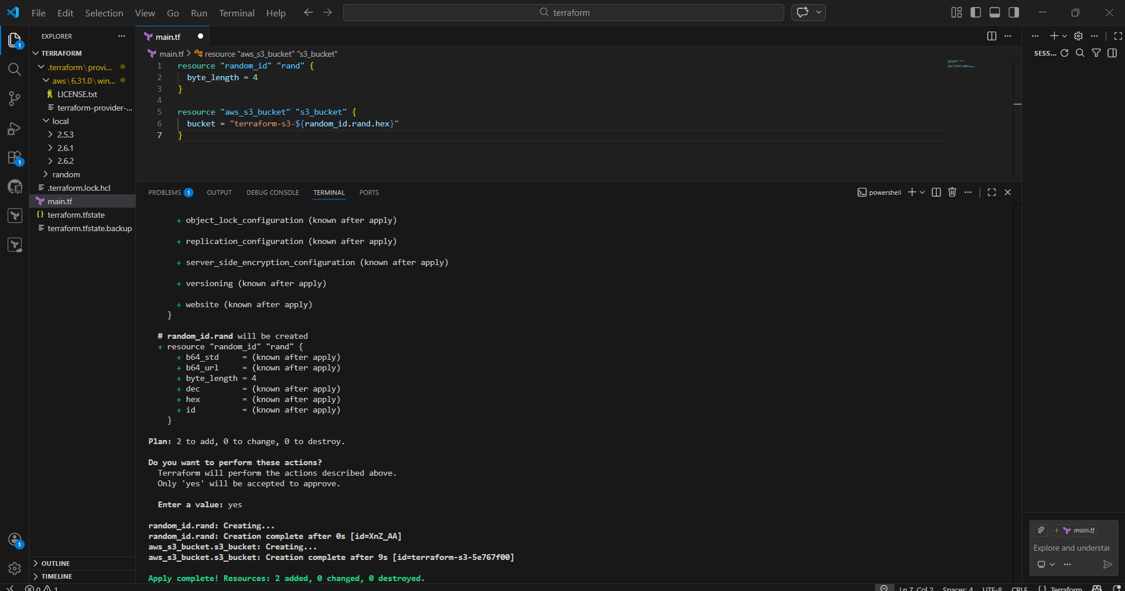

- Login to AWS Console.
- Go to:
S3 → Buckets
- Search bucket name: ironman3000
- Confirm bucket exists in the bucket list
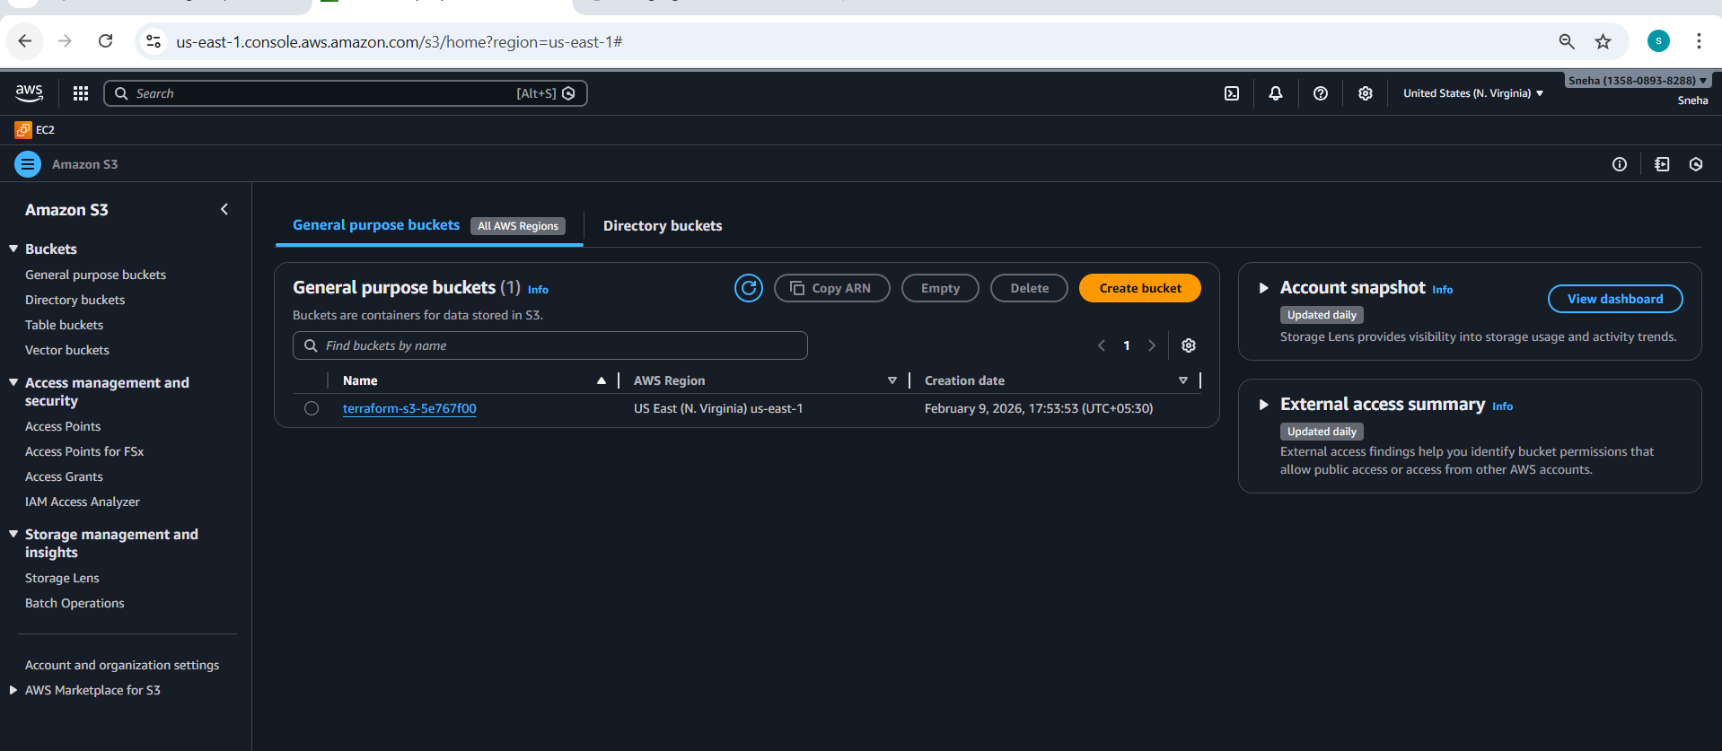
- Open main.tf in VS Code.
- Keep existing S3 bucket code.
- Add DynamoDB table resource below it:
- resource "aws_dynamodb_table" "dynamodb-terraform-state-lock" {
- name = "terraform-state-lock-dynamo"
- hash_key = "LockID"
- read_capacity = 20
- write_capacity = 20
- attribute {
- name = "LockID"
- type = "S"
- }
- }
- Save the file.
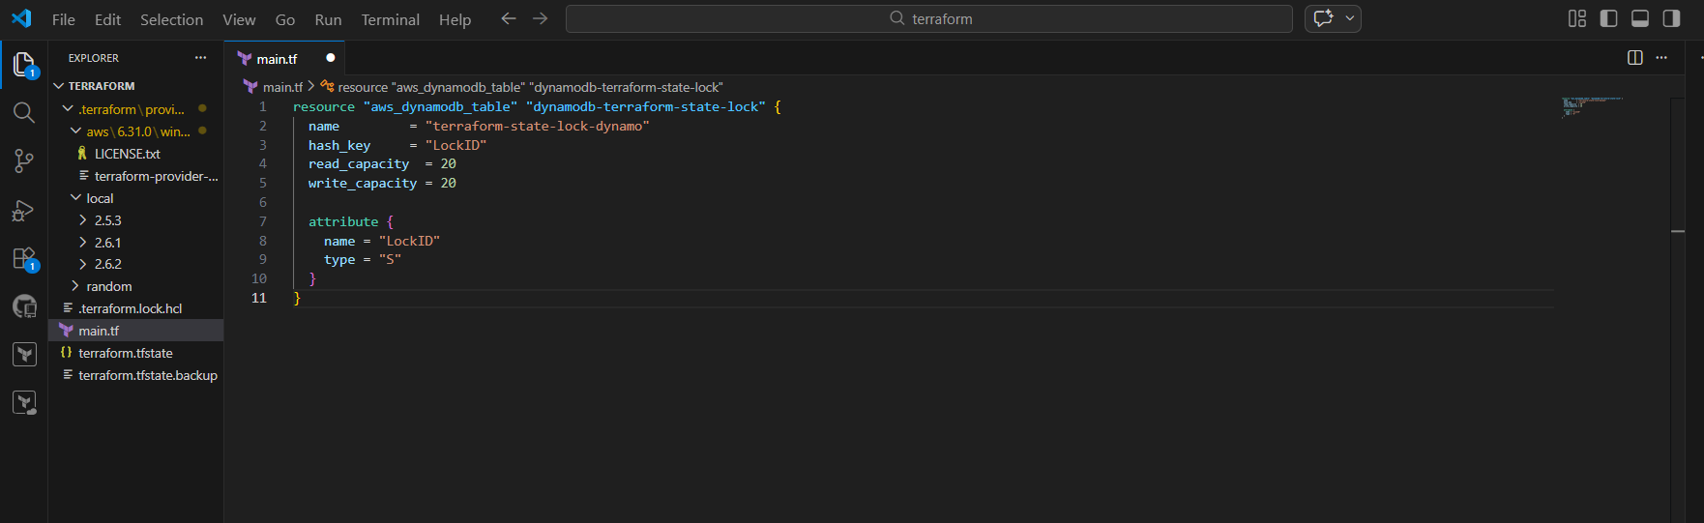
- Open terminal in VS Code.
- Run again:
- terraform init
Confirm initialization is completed successfully
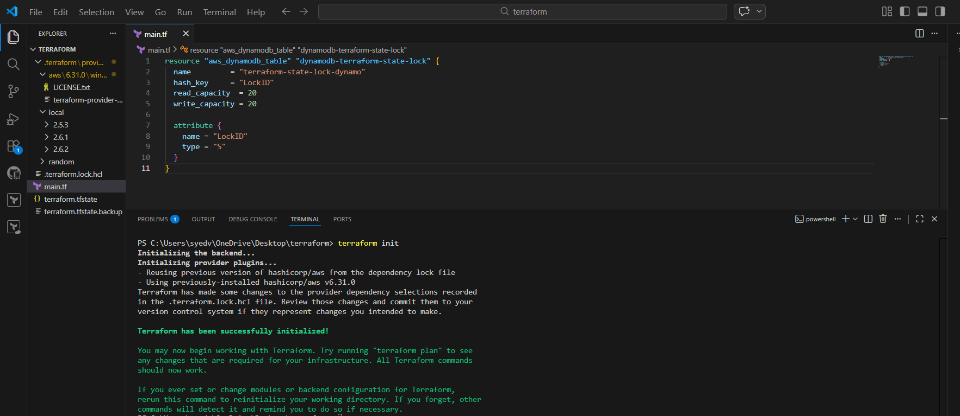
- Run:
- terraform apply
- Terraform shows plan and indicates:
- aws_dynamodb_table.dynamodb-terraform-state-lock will be created
- Proceed to approval step
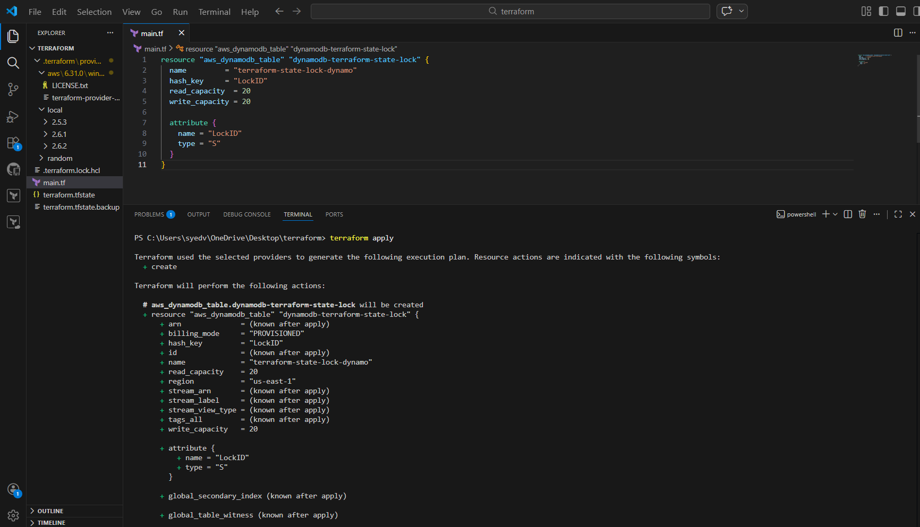
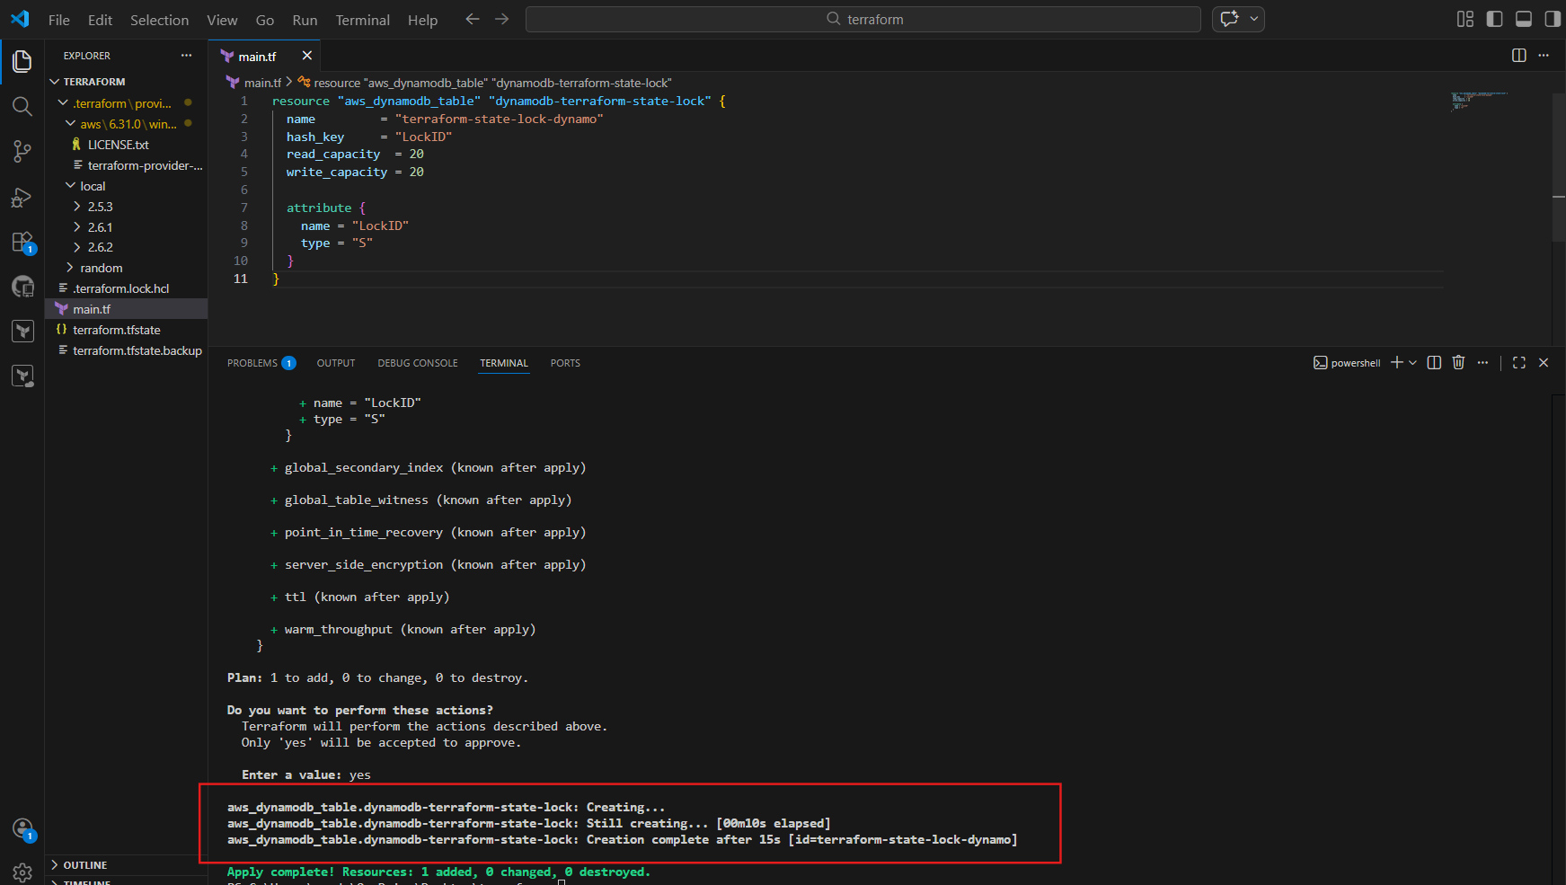
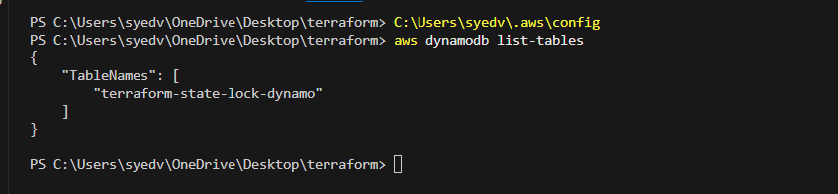
- Login to AWS Console.
- Go to:
DynamoDB → Tables
- Confirm table exists:
- terraform-state-lock-dynamo
- Status should show Active
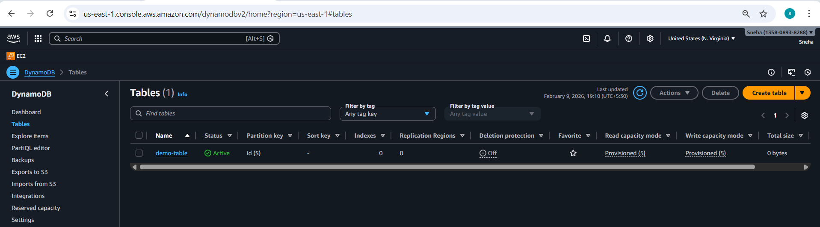
- Open main.tf.
- Replace deprecated S3 ACL line with proper ACL resource:
- resource "aws_s3_bucket" "s3_bucket" {
- bucket =

- }
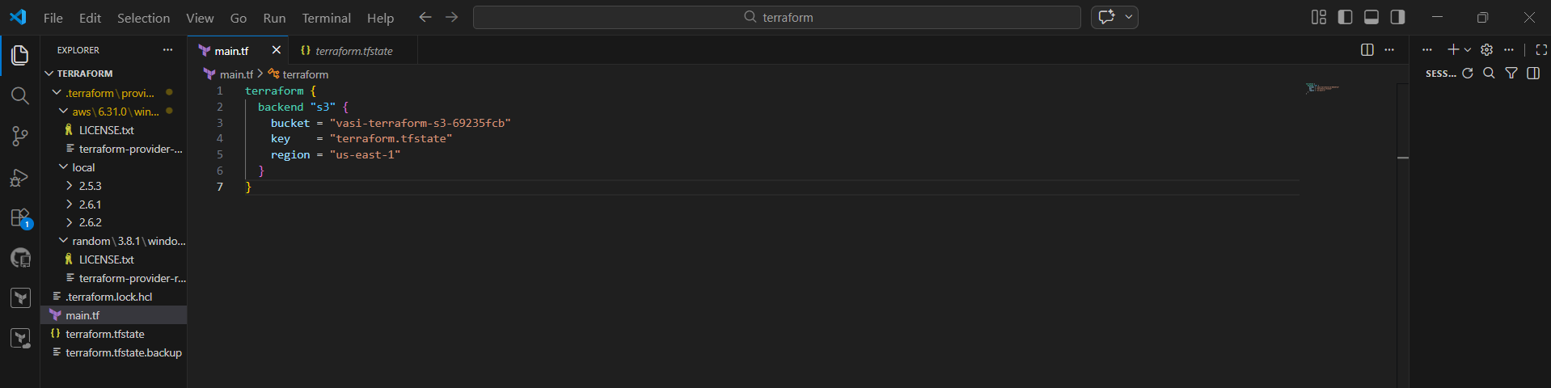
- check the terraform.tfstate in terraform
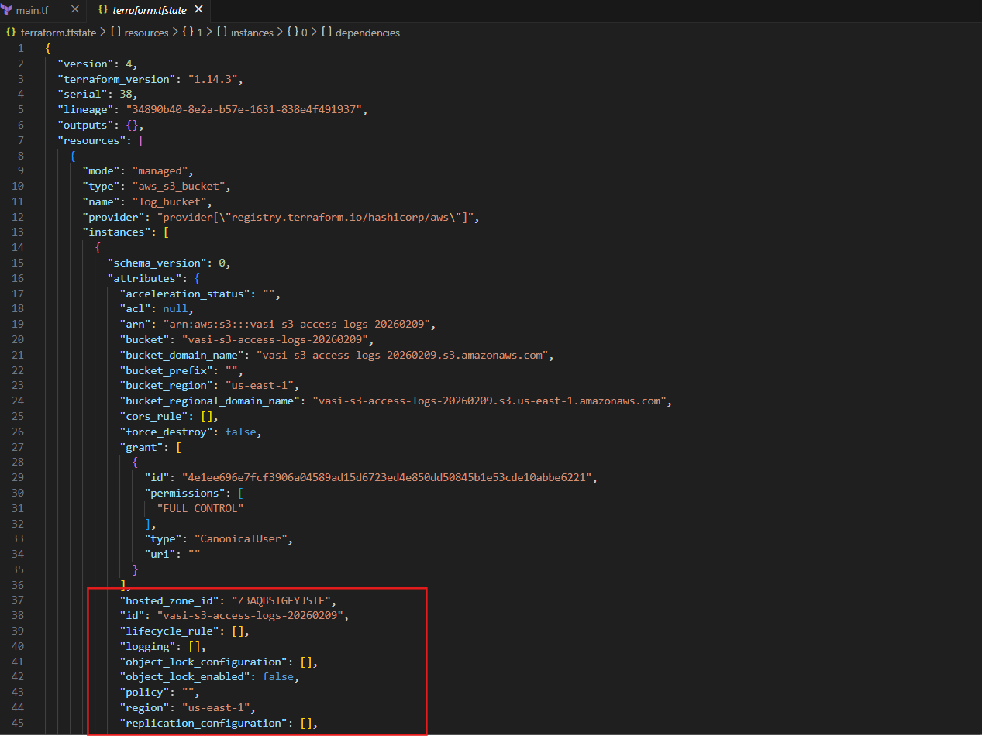
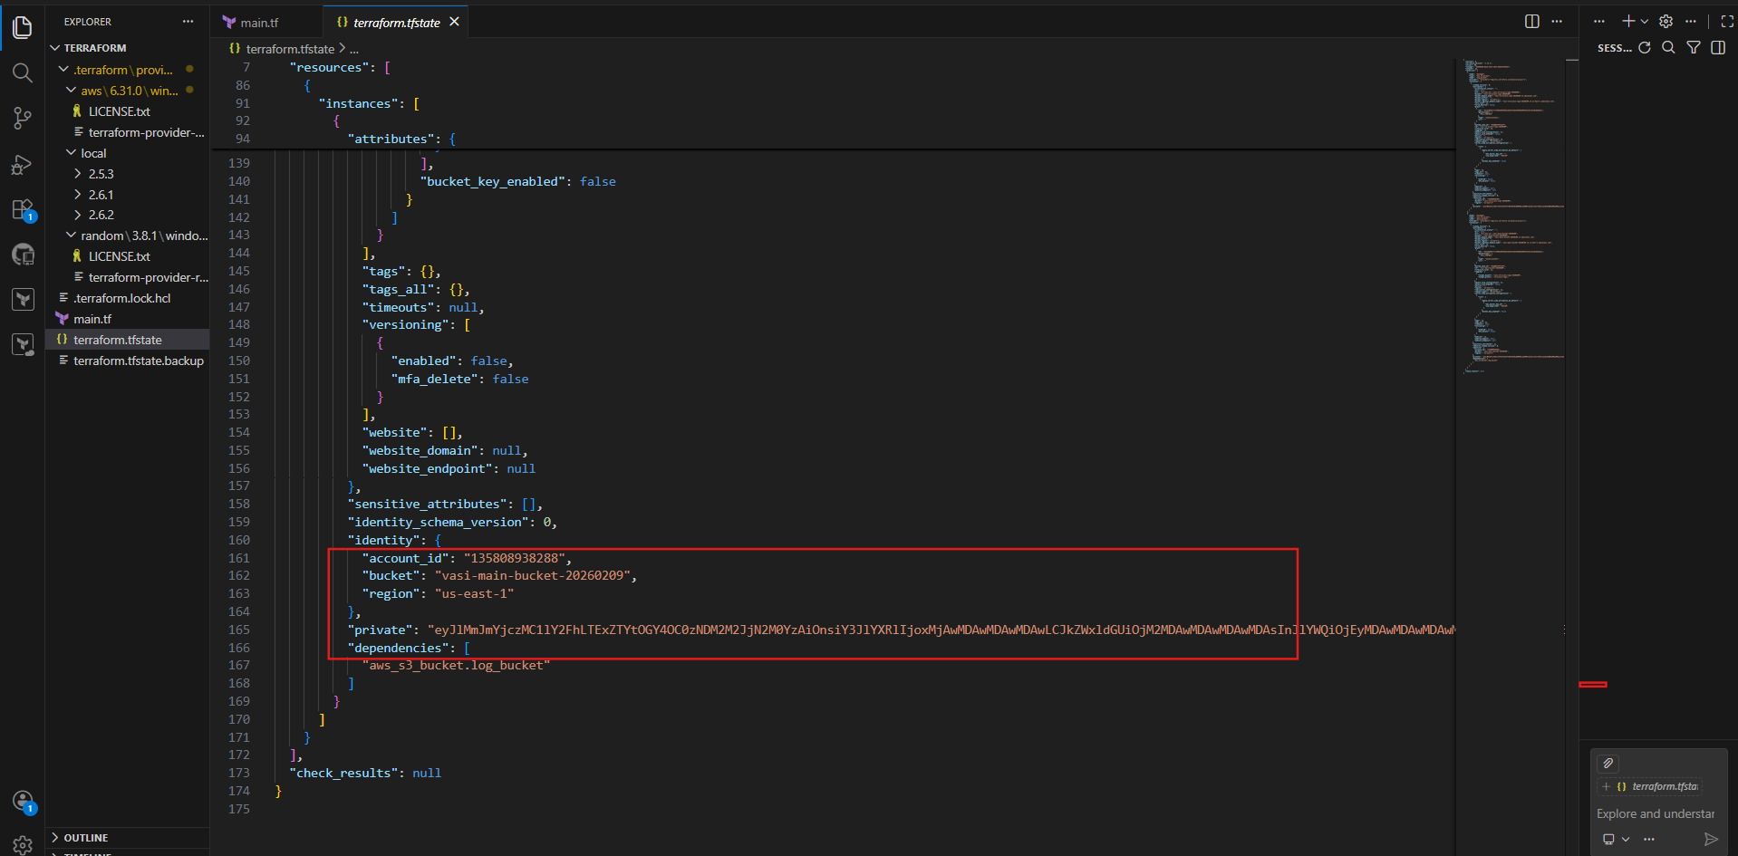

3. Create one EC2 instance with httpd installed using a Terraform script.
- My ec2 console I empty
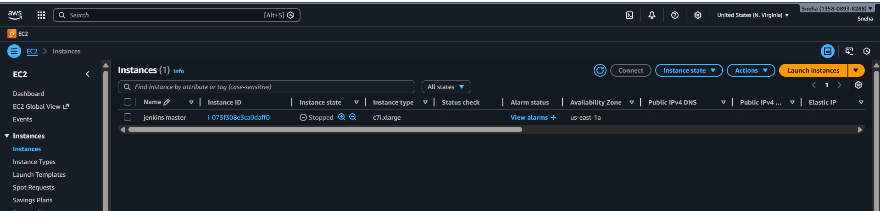
- Write the terraform script to create the ec2
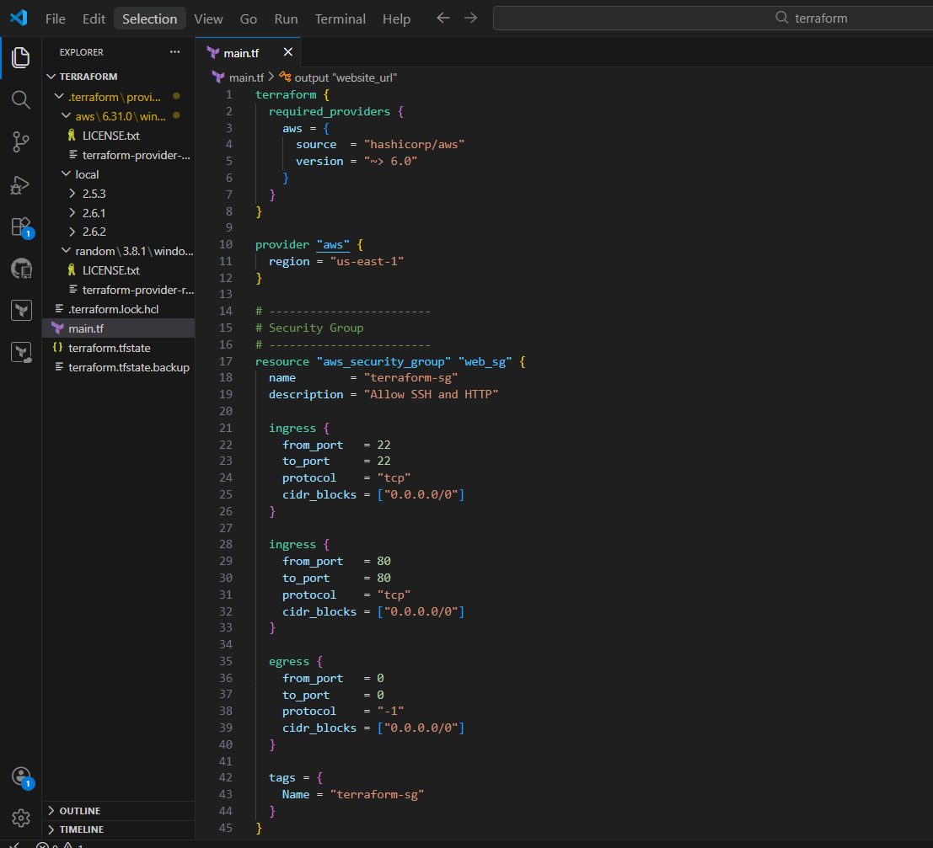
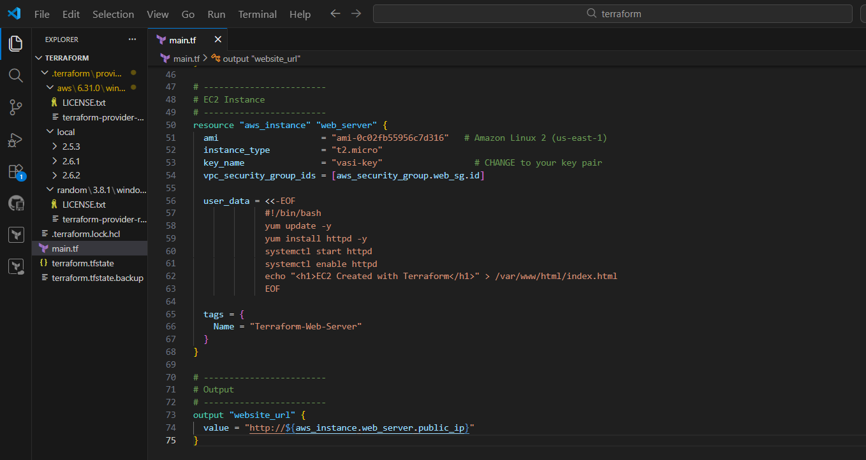
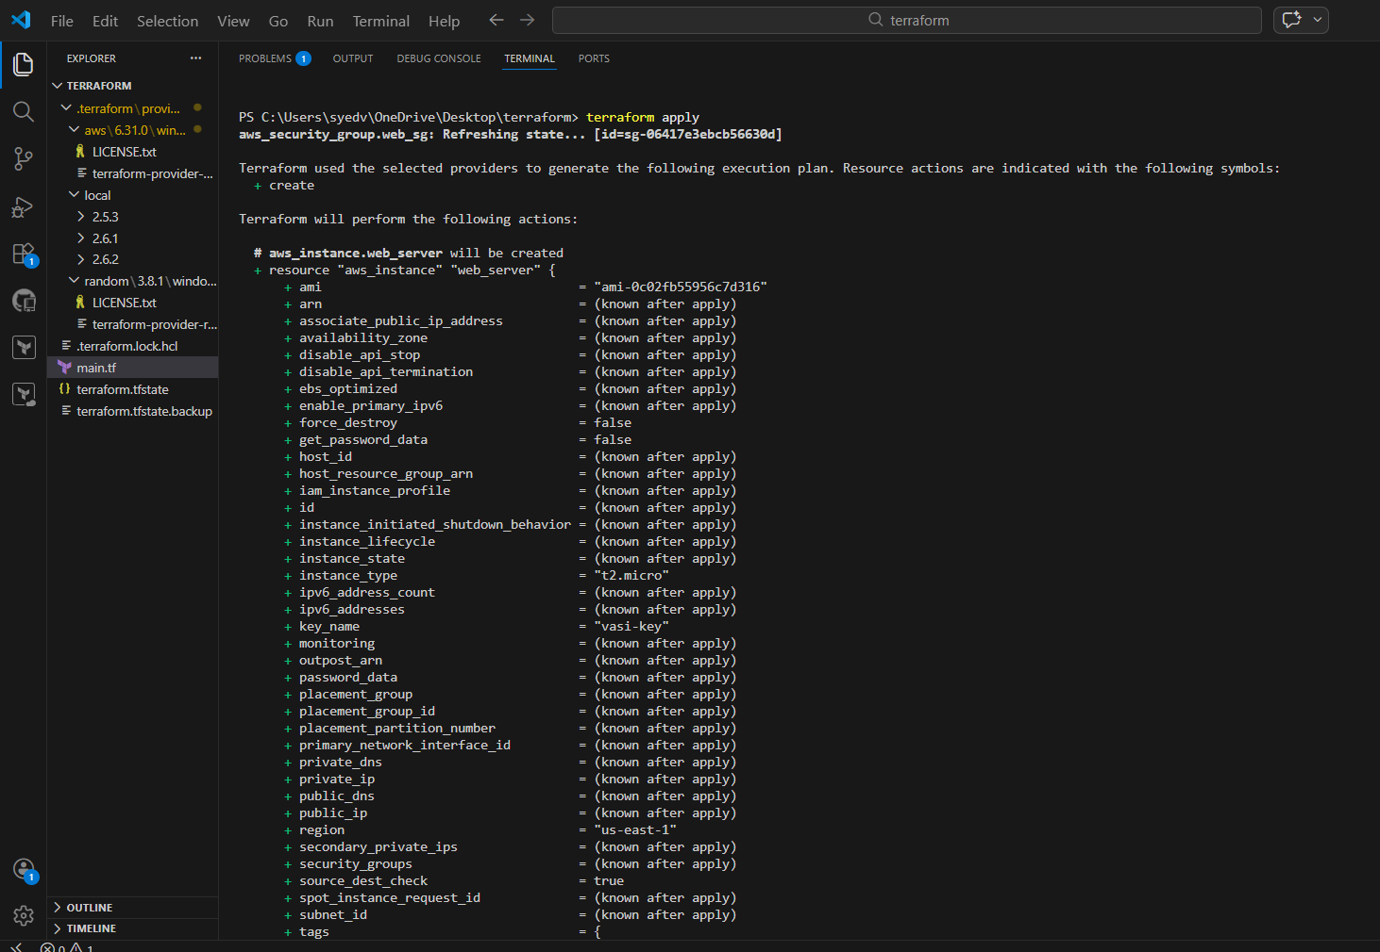
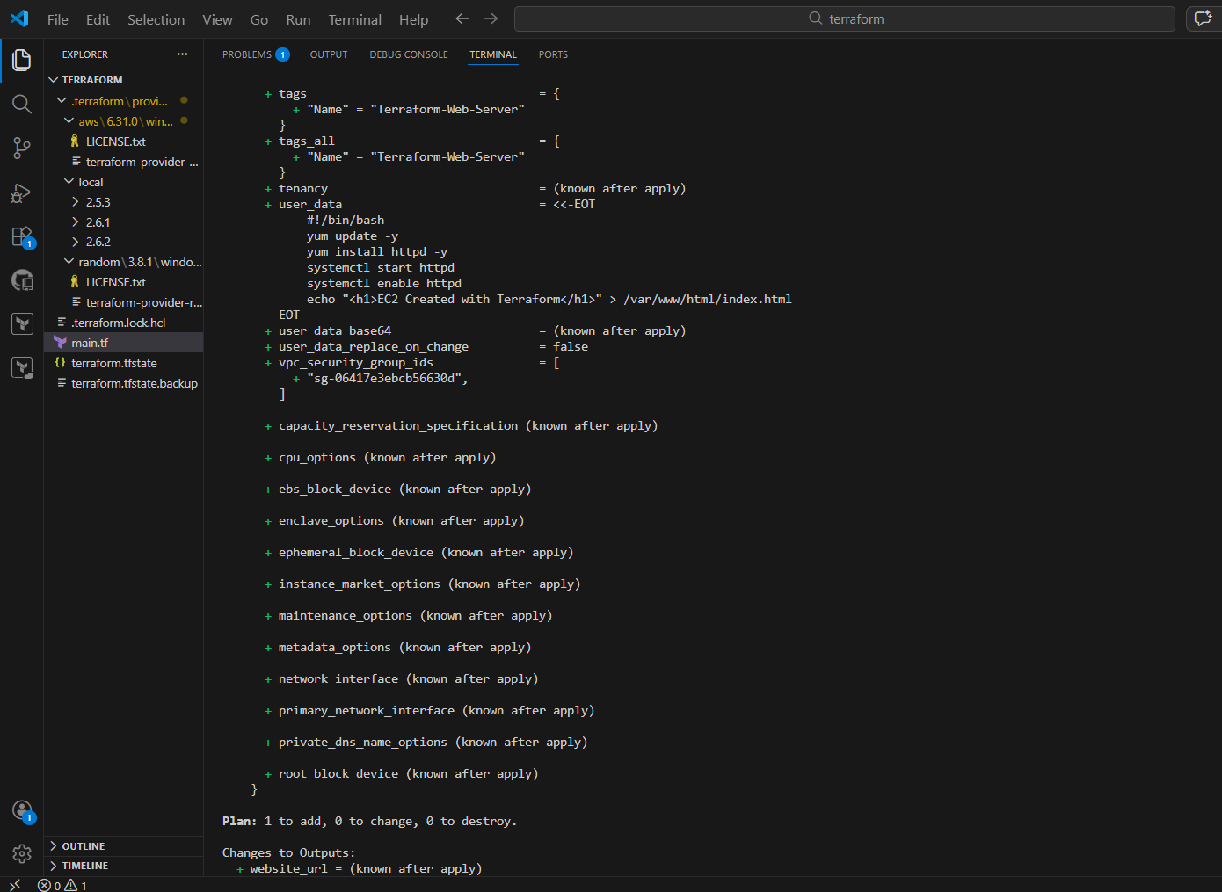
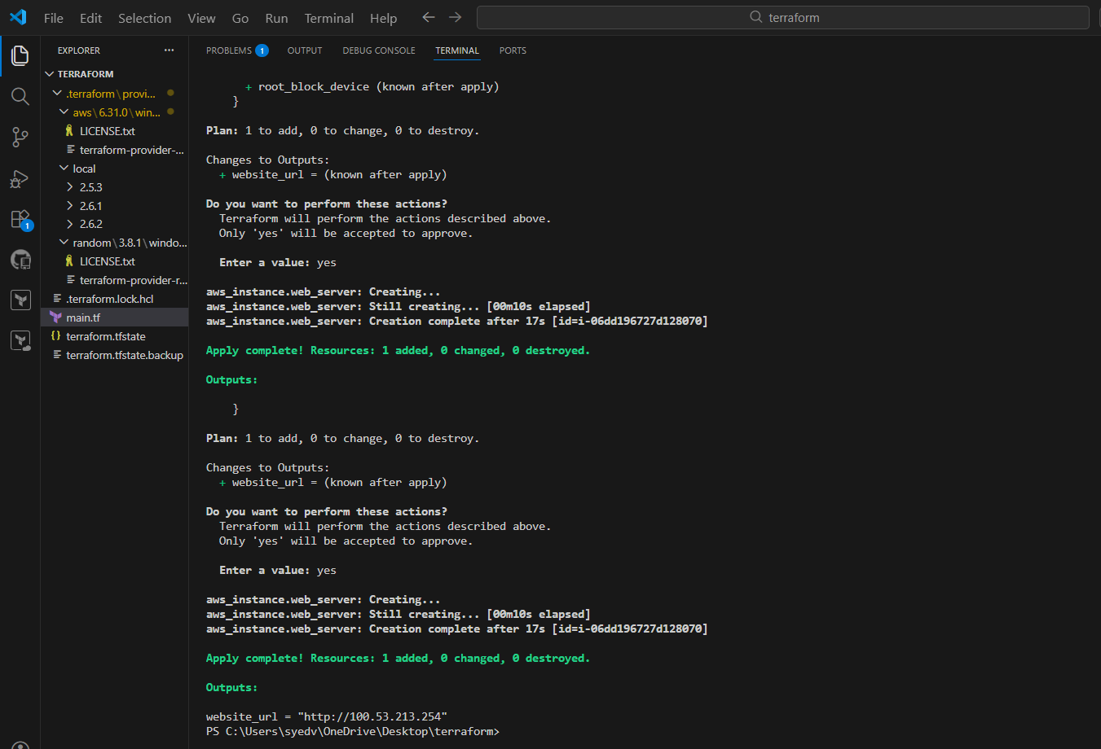
- Ec2 is created
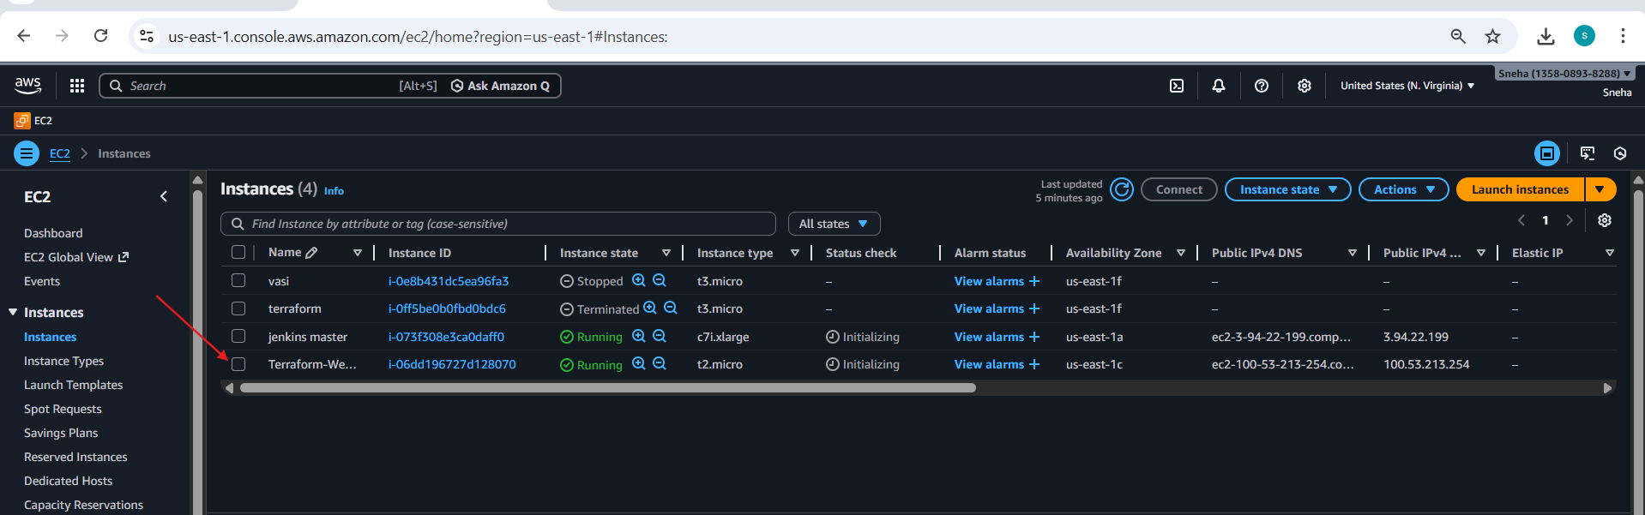

- See the proper details
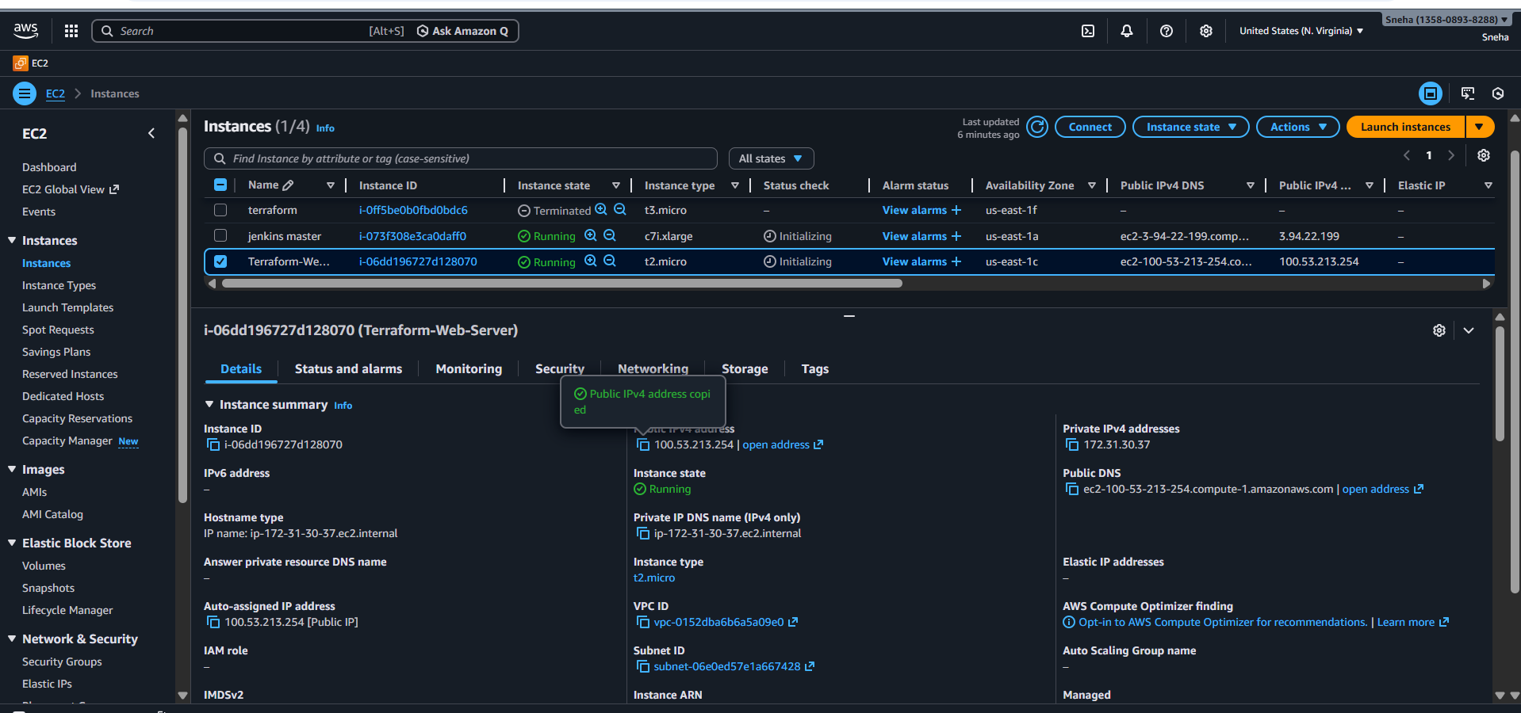
- Check if script is running or not
- So my script is running successfully
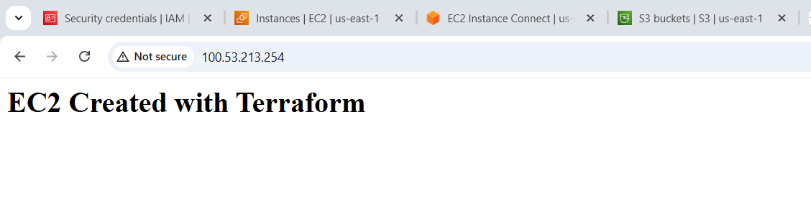

4. Set up S3 as backend for task 3.
Create the s3 bucket
Currently by bucket is empty
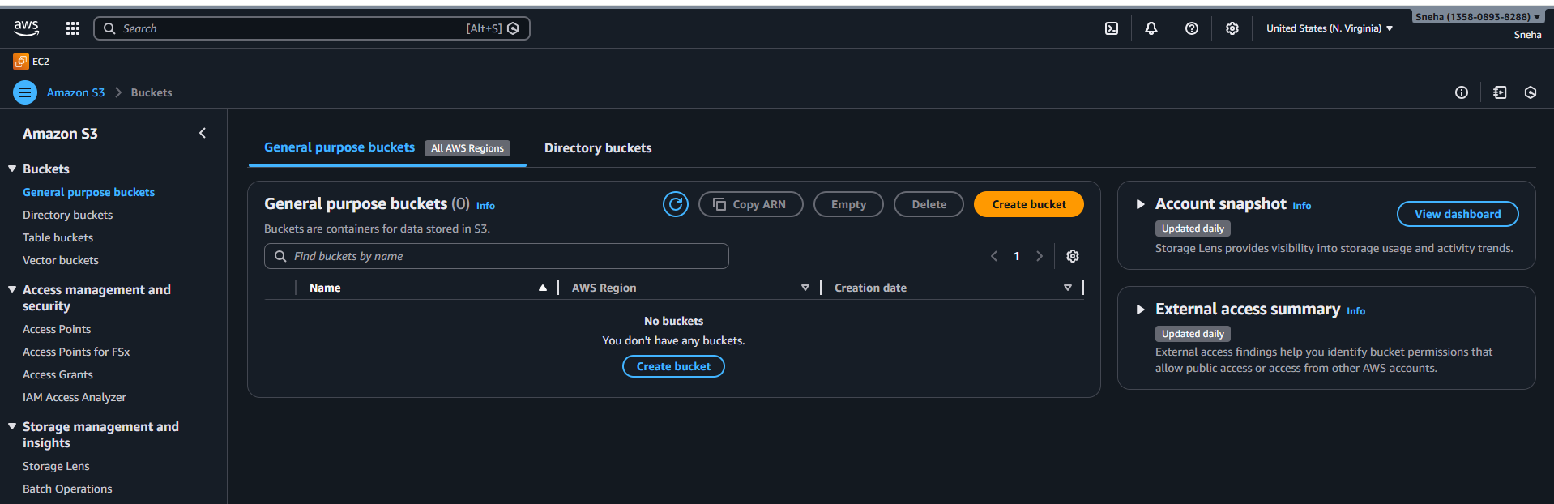

- Write the proper script to create the s3 bucket
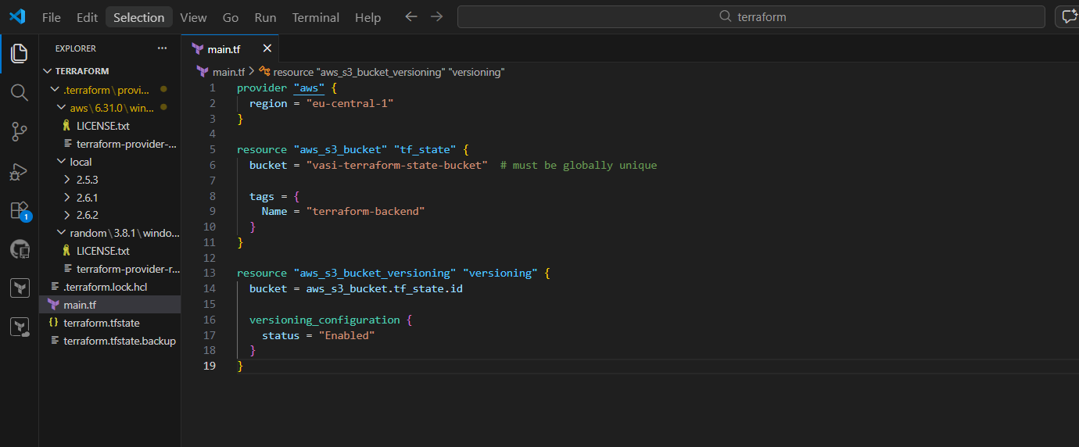
- Execute the script
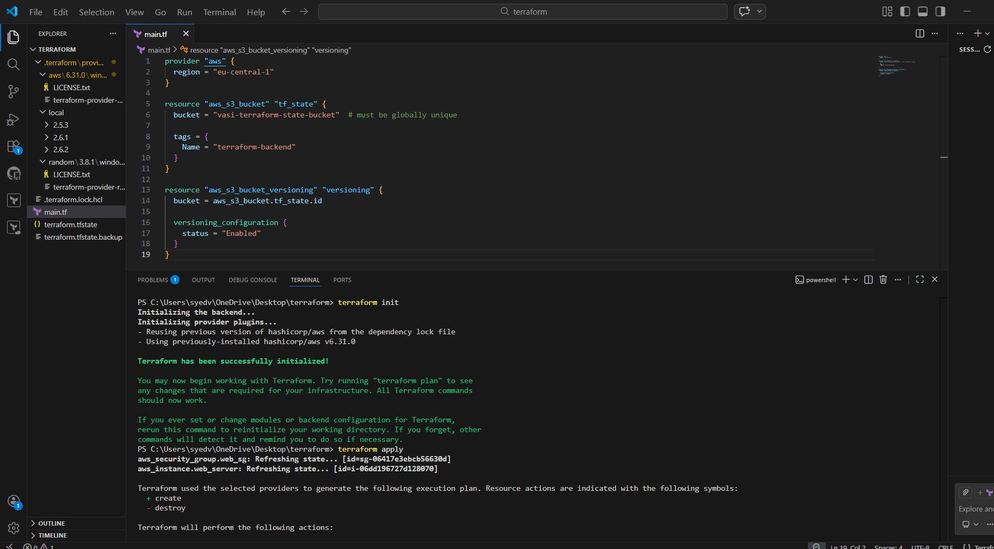
- Bucket is created sucessfully
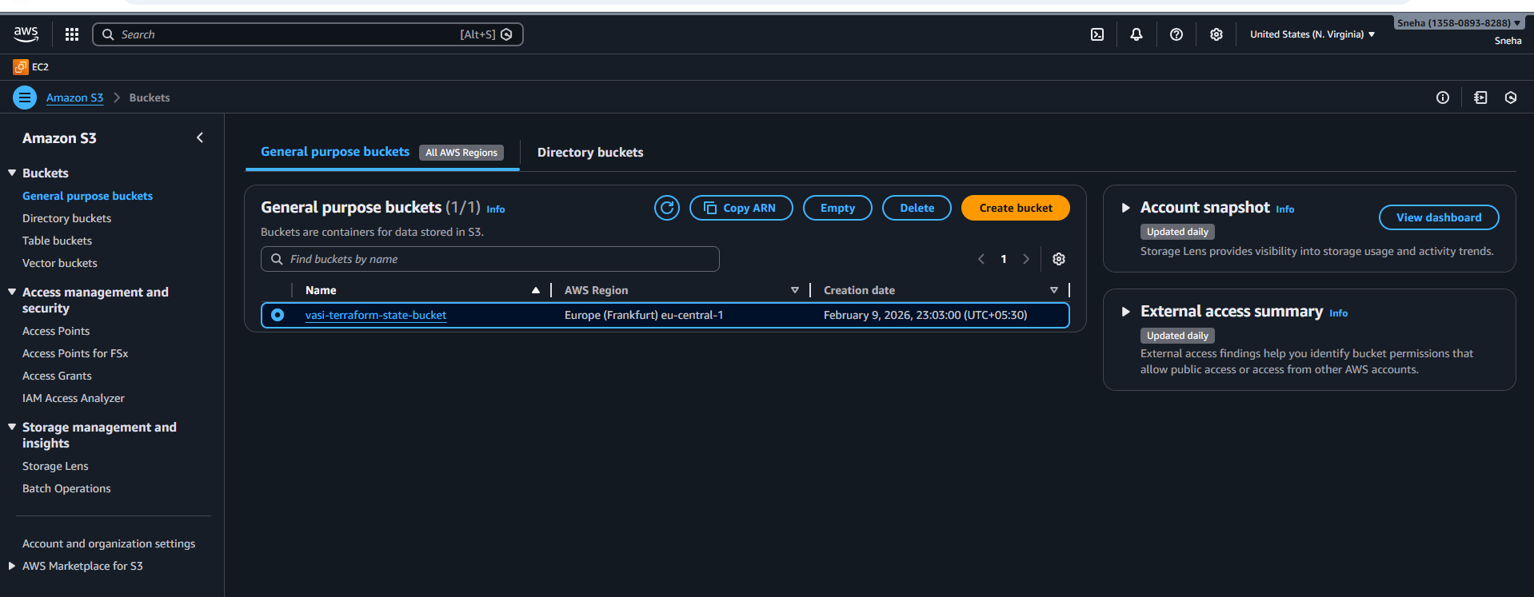
- Put the objects in the bucket
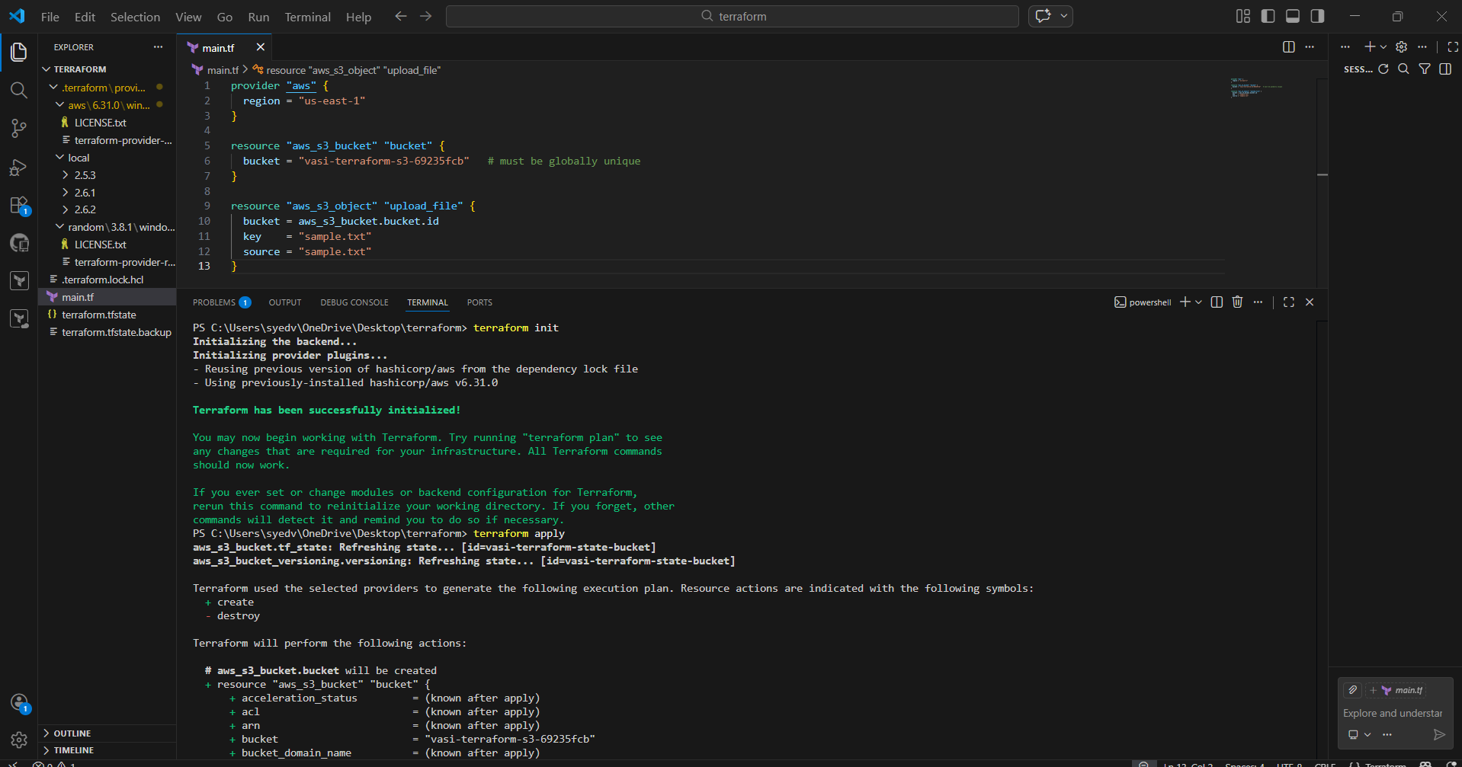
- apply the objects through the vs
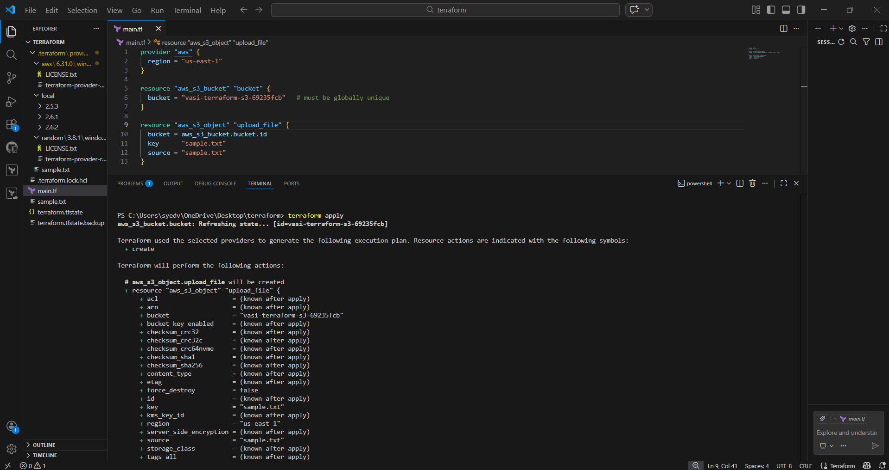
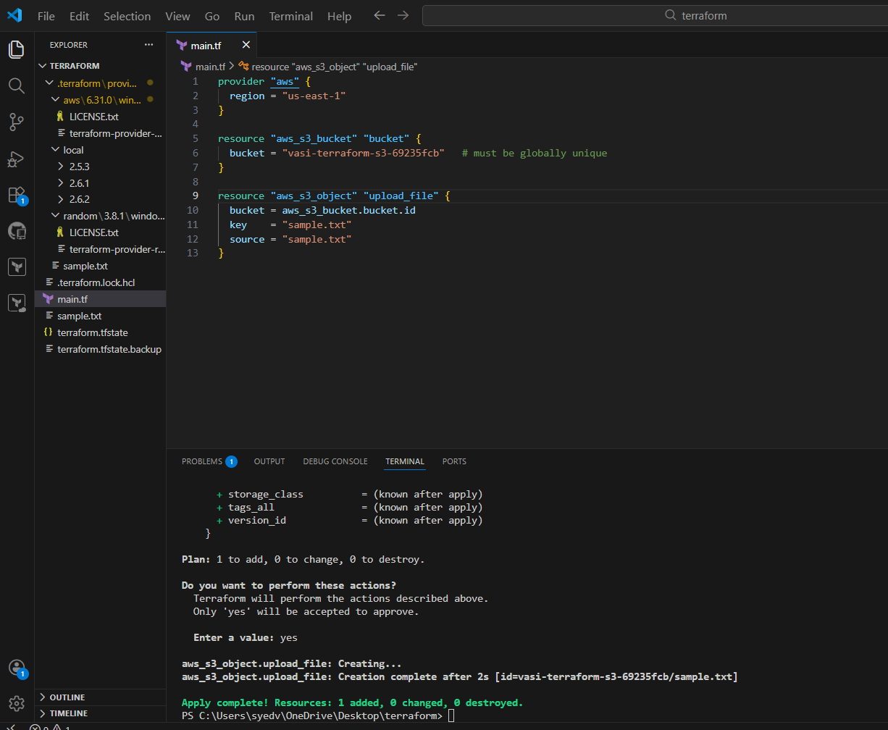

- The objects is uploaded successfully
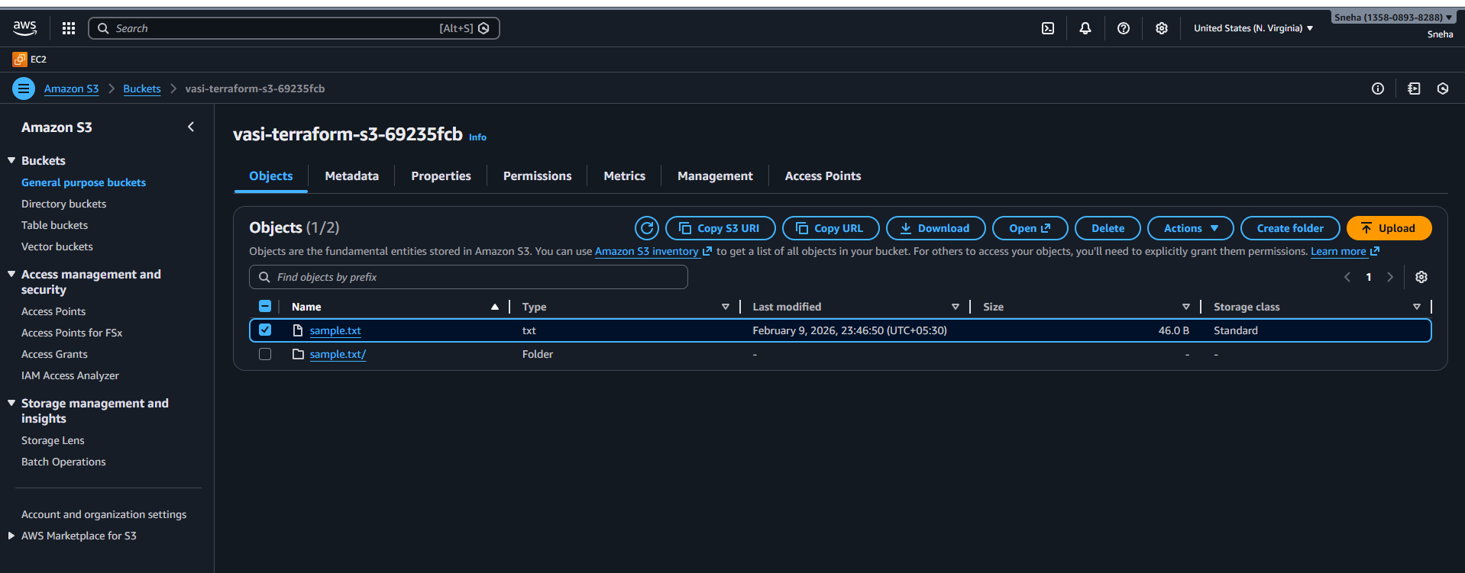

- Check the properties
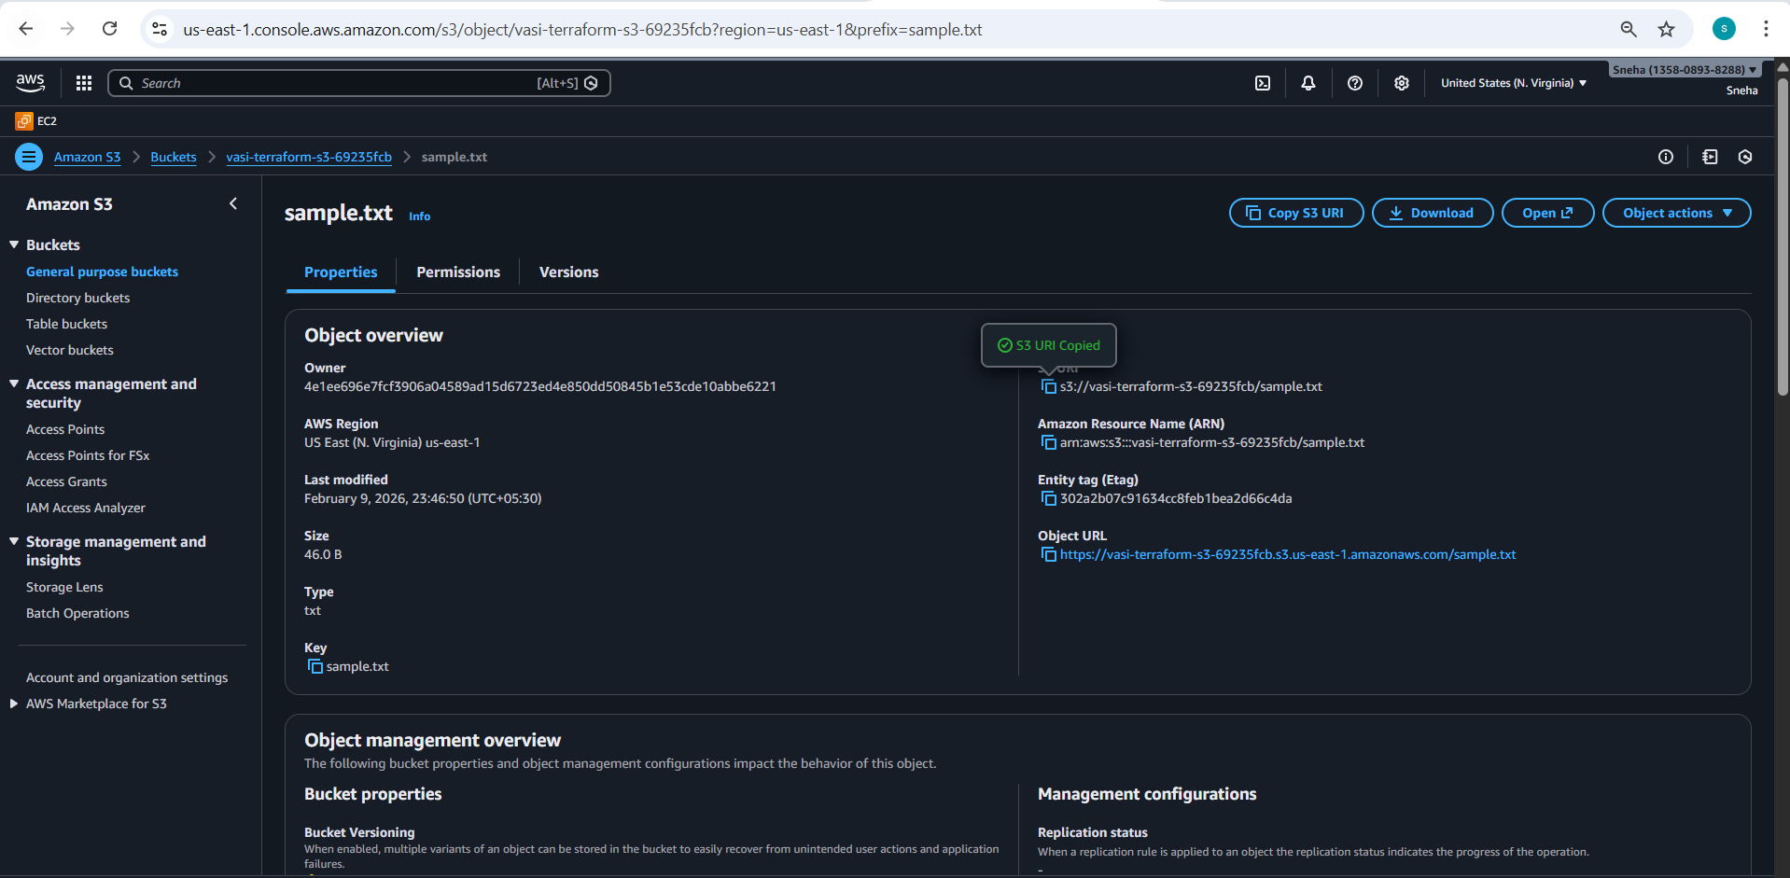

5. Set up DynamoDB locking for task 3.
Already I have created the databse
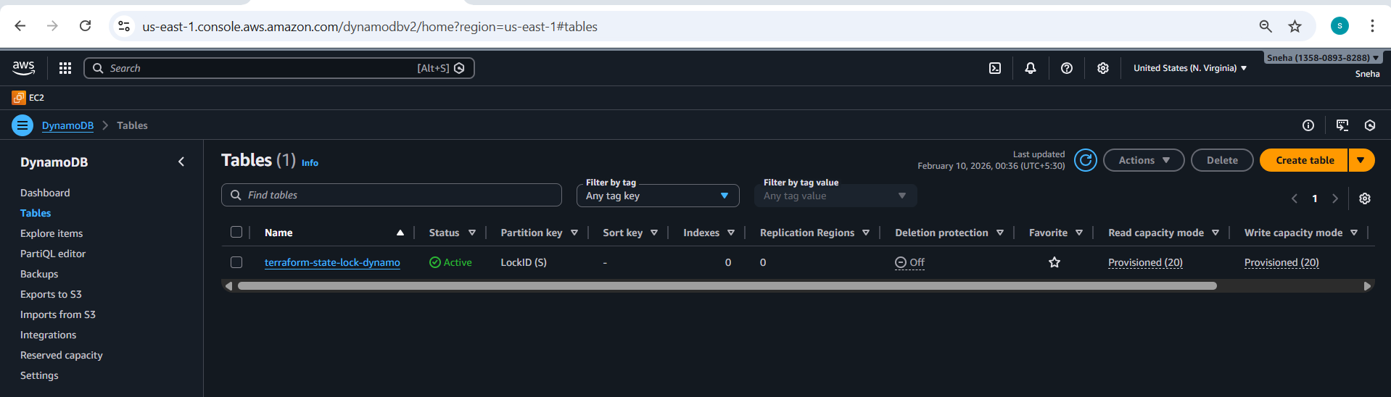

- Setting the database to the ec2
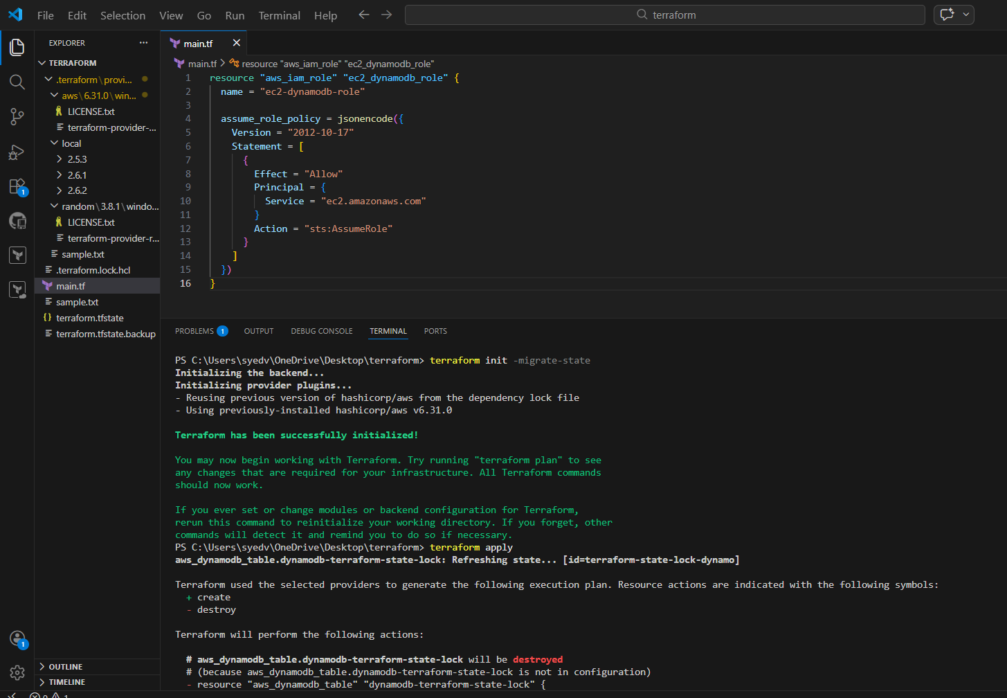
- Data base has successfully applied
